Lab_Day-25 ANP-C8906 (Pandas Series)

1: Suppose you are a teacher, and you want to analyze the exam scores of your students in a particular subject. You have recorded the scores of your students for a recent exam, and you want to represent this data using a Pandas Series.

Input: students = ['Alice', 'Bob', 'Charlie', 'David', 'Eve', 'Frank', 'Grace', 'Hannah', 'Ivy', 'Jack'] exam_scores = [92, 88, 76, 94, 82, 90, 85, 89, 78, 91]

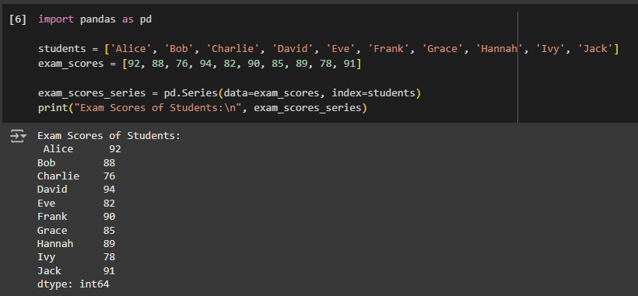

2: Suppose you want to track and analyze your household expenses for a month. You have recorded the expenses for various categories, such as groceries, utilities, rent, transportation, and entertainment. You can represent this expense data using a Pandas Series.

Input: # Expense categories categories = ['Groceries', 'Utilities', 'Rent', 'Transportation', 'Entertainment']

# Monthly expense data (example data in USD) expenses = [500, 200, 1200, 300, 150]

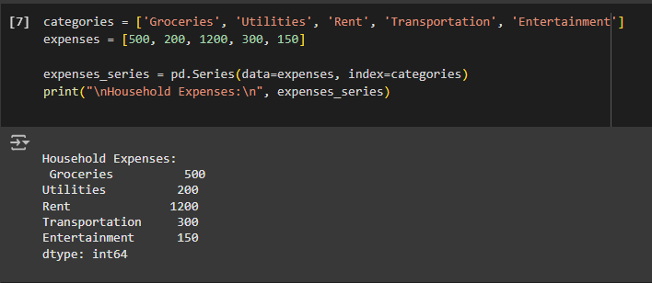

3: Suppose you want to track and analyze the monthly energy consumption in your home. You have recorded the monthly energy usage for electricity and gas over a year, and you want to represent this data using Pandas Series.

Input: # Months in a year months = ['January', 'February', 'March', 'April', 'May', 'June', 'July', 'August', 'September', 'October', 'November', 'December']

# Monthly energy consumption data (example data in kilowatt-hours for electricity and therms for gas) electricity_usage = [350, 320, 310, 330, 340, 370, 380, 360, 350, 330, 320, 330]

gas_usage = [20, 18, 16, 15, 12, 10, 8, 9, 12, 15, 17, 19]

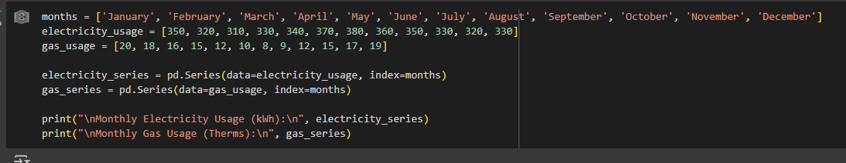

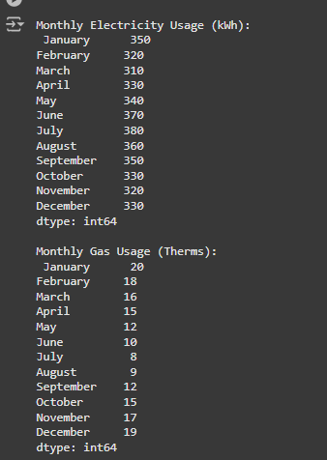

4:Suppose you are managing a website and want to analyze the monthly revenue generated from advertising. You have recorded the monthly revenue for the past year, and you want to represent this data using a Pandas Series.

Input: # Months in a year months = ['January', 'February', 'March', 'April', 'May', 'June', 'July', 'August', 'September', 'October', 'November', 'December']

# Monthly advertising revenue data (example data in USD)

revenue = [5000, 5200, 4800, 5400, 5600, 5800, 6100, 5900, 6200, 6500, 7000, 6900]

